PRESS RELEASE

SUPERIOR SAFETY FOR LITTLE EFFORT

WITH ITS DECENTRALIZED MOTOR STARTER PODIS MS 5HP, WIELAND ELECTRIC SUPPORTS THE SIMPLE PLANNING AND SAFE OPERATION OF CONVEYOR SYSTEMS

Large space take-up in the control cabinet, bulky cable trays and complex distributor box installation: If motors in conveyor systems are safely switched off in the conventional way, the wiring and energy distribution involved is usually very complex. Wieland Electric wanted to reduce the complexity in installation and make it more user friendly. This drive ultimately led to the development of the motor starter podis MS 5HP The extremely compact, robust and user-friendly drive component has an integrated STO (Safe Torque Off) function, which renders the connected motor torque-free in case of need and allows the power supply to be completely disconnected from the emergency stop circuits. As a result, the STO circuits no longer need to be routed to a central distributor over long distances and assigned to a specific energy branch. This makes the system less susceptible to interference and creates significant advantages for planning and installation work.

This innovative combination of starter functions allows all the energy to be distributed and decentralized assignment of STO circuits in the field. In addition, a superior level of safety (SIL 3, PL e) can be achieved for little effort. All the motor starters in an emergency stop circuit are connected to the STO female sockets and the STO circuit is monitored and operated via an auxiliary voltage generated in the field and also by a two-channel safety relay. In addition, several STO circuits can be operated from one power supply.

If an energy bus system such as the podis 5G6 from Wieland Electric is used, further benefits of separating energy and signal come into play: Because the energy distribution for several motor starters and motors can be combined on one line with only a single feed. This saves space in the cable trays and the wiring in the distributor panel is much simpler.

Besides that, the podis MS 5HP is designed so that a single size can cover a power range from 0.25 kW to 4.0 kW. This helps reduce storage and administration costs. Because there is only one order option, the procurement and materials management processes also require less effort.
Installation and commissioning procedures are also simply designed: The motor starter can be fully programmed via DIP-switches. Guided through the procedure step-by-step by an intelligent web configurator guide, the user can make the settings for the motor and the application concerned. The configurator and further information about the motor starter can be accessed by simply scanning the QR code on the front of the device using a smartphone or tablet.

With international approvals CE, cULus from Q4 2021, the podis MS 5HP is suitable for worldwide use. On the US market in particular, it fulfills the required operating standards, including the design of the disconnector switch in accordance with UL 508. This is an integrated service switch that is designed to safely switch off drives for maintenance or repair work by disconnecting individual conveying lines or consumers from the power supply without the system as a whole having to be shut down. A special integrated power supply, which generates the 24V DC auxiliary voltage required to supply the connected sensors without using the neutral conductor, and hence makes additional separate wiring unnecessary, offers another advantage. This saves time and reduces material costs. Designed compliant with protection class IP65 and the NEMA12 standard relevant for the US market, the podis MS 5HP is also suitable for use in harsh industrial environments.

IMAGE MATERIAL
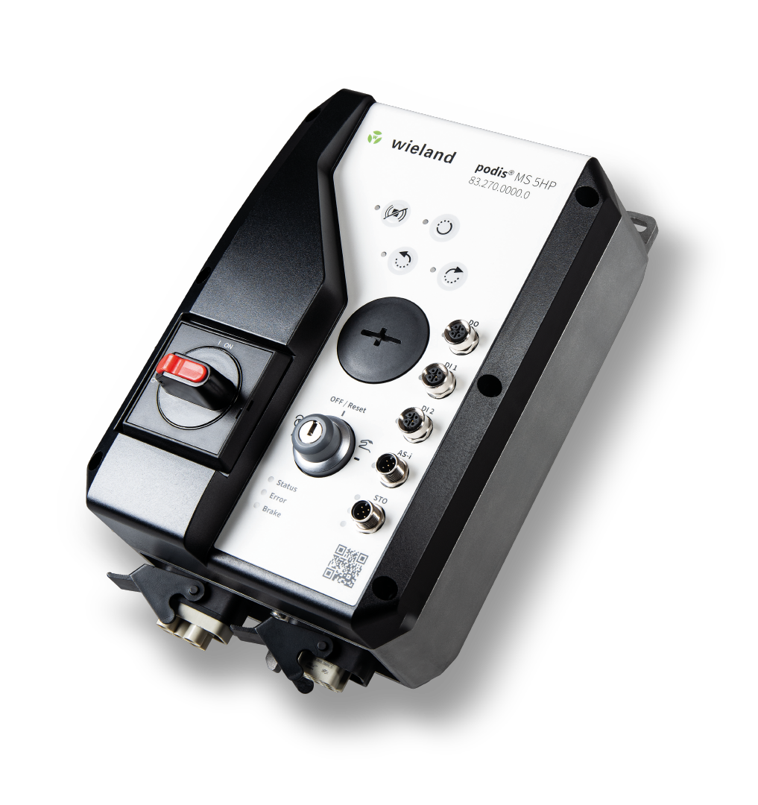

With its integrated STO function, the compact and robust motor starter podis MS 5HP from Wieland Electric not only contributes to safe operation, it also makes the planning and installation involved in the wiring and energy distribution of expansive systems less complex.

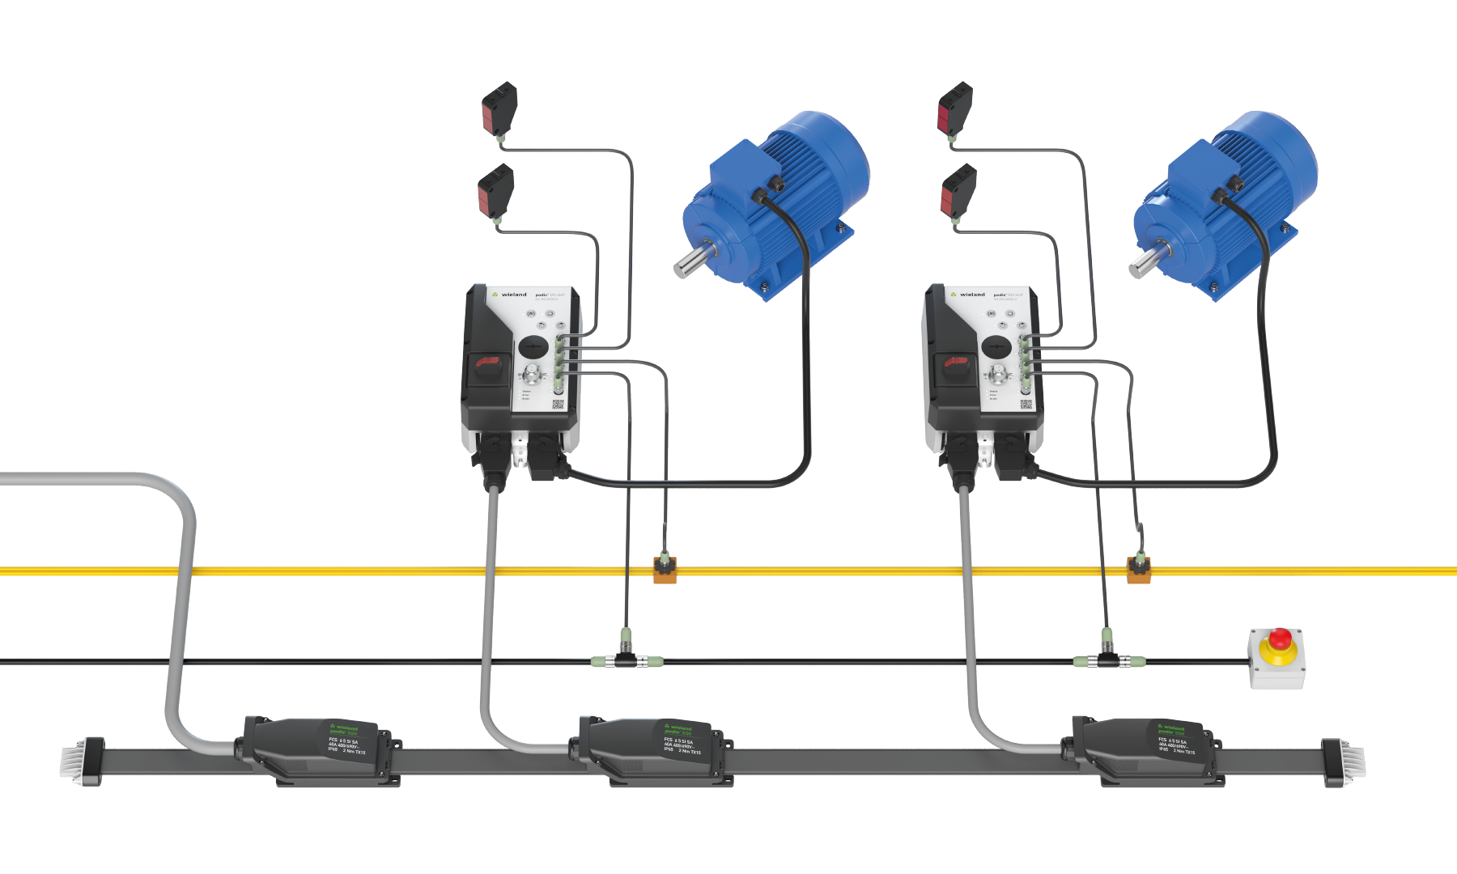

Being compatible with the podis energy bus system from Wieland Electric, the decentralized motor starter can play to all its strengths within an optimally matched system.

ABOUT WIELAND ELECTRIC

Wieland Electric, founded in Bamberg in 1910, is the inventor of safe electrical connection technology. Today, the family-owned company is one of the leading suppliers of safety and automation technology and has been the global market leader in the field of pluggable electrical installations for building technology for over 30 years.

Wieland Electric assists customers with on-site support all over the world as a capable service partner and solution provider. This is possible thanks to around 1,600 employees and subsidiaries as well as sales organizations in over 70 countries. In addition to Wieland Electric GmbH, STOCKO Contact GmbH & Co. KG has belonged to Wieland Holding since 1998.

The company’s core industries are mechanical engineering, wind power, intralogistics, HVAC and
building and lighting technology. The broad portfolio includes components, products and solutions for electrical installation, connection technology, power distribution, safety technology and the control cabinet. Wieland Electric also offers an extensive service and training program. With cross-industry experience, a great product diversity and numerous service offerings, the company has consistently developed from a component supplier to a solution provider in recent years.

YOUR PRESS CONTACT

WIELAND ELECTRIC GMBH
Alexander Viertmann / Marketing Communication
Phone: +49 951 9324 316
E-mail: communications@wieland-electric.com
Internet: www.wieland-electric.de

MARION NIKOL
COMMUNICATION FOR INDUSTRY & TECHNOLOGY
Phone: +49 170 2731025
E-mail: info@intecsting.de
Internet: www.intecasting.de

